**PHASE 2**

Project Title : **FAKE NEWS DETECTION USING NLP**



Name : Keerthana.L

Register no : 210521205028

**Introduction :**

Fake news is false or misleading information presented as news. The proposed study uses natural language processing approaches to identify false news—specifically, false news items that come from unreliable sources.

Fake news and disinformation are ongoing problems that may be found all around us in biased software that amplifies just our viewpoints for a "better" and smoother user experience.

In this paper, we are focusing on the fake news detection in text media. Machine learning and deep learning techniques for fraud detection has beenthe subject of extensive study, most of which has concentrated on categorising online reviews and publicly accessible social media posts.

**STEPS & STRATEGIES :**

**1. Data Gathering and Labeling:** Collect a diverse and comprehensive dataset of news articles, ideally with both real and fake examples, and label them accurately.

**2. Data Preprocessing:** Clean and preprocess the text data. This includes tasks like tokenization, removing special characters, stemming or lemmatization, and handling imbalanced datasets.

**3. Feature Extraction:** Extract meaningful features from the text data. Common techniques include TF-IDF, word embeddings (e.g., Word2Vec or GloVe), or leveraging pre-trained models like BERT for contextual embeddings.

**4. Model Selection:** Choose an appropriate NLP model for fake news classification. Deep learning models such as recurrent neural networks (RNNs), convolutional neural networks (CNNs), or transformer-based models (e.g., BERT, GPT) are commonly used.

**5. Model Training:** Train the selected model on the preprocessed data. Fine-tune hyperparameters, and use techniques like dropout and batch normalization to prevent overfitting.

**6. Evaluation Metrics:** Use appropriate evaluation metrics like accuracy, precision, recall, F1-score, and area under the ROC curve (AUC-ROC) to assess the model's performance.

**7. Cross-Validation:** Implement cross-validation techniques like k-fold cross-validation to ensure the model's generalization and robustness.

**8. Ensemble Methods:** Consider using ensemble methods like bagging or boosting to combine the predictions of multiple models for improved accuracy.

**9. Explainability:** Incorporate explainability techniques (e.g., LIME or SHAP) to understand why the model makes certain predictions, enhancing transparency and trust.

**10. Feature Importance Analysis:** Analyze feature importance to identify which words or phrases contribute most to fake news detection.

**11. Continuous Learning:** Implement mechanisms for continuous learning, allowing the model to adapt to new fake news tactics and emerging trends.

**12. User Interface:** Create a user-friendly interface that allows users to submit news articles for analysis and provides clear feedback on the article's credibility.

**13. Feedback Loop:** Establish a feedback loop where user feedback and model predictions can be used to improve the system's performance over time.

**14. Ethical Considerations:** Address ethical concerns such as bias in data, fairness, and privacy when implementing the system.

**15. Deployment:** Deploy the model in real-world scenarios, either as a standalone application or integrated into news platforms and social media networks.

**16. Monitoring and Maintenance:** Continuously monitor the system's performance, retrain the model periodically, and address any issues that may arise.

**17. User Education:** Educate users about the limitations of the system and the importance of critical thinking when consuming news.

**18. Collaboration:** Collaborate with experts in journalism and fact-checking organizations to improve the accuracy of the system.

**Diagram :**

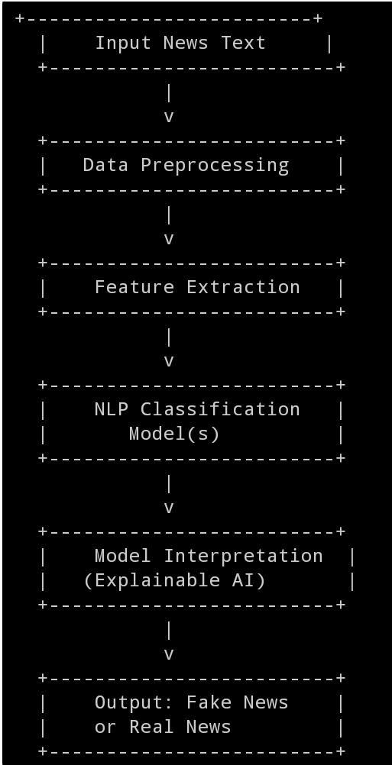

**Conclution :**

The manual classification of false political news requires for a deeper understanding of the field. The problem of predicting and categorizing data in the fake news detection issue needs to be confirmed using training data. Reducing the amount of these features could increase the accuracy of the fake news detection algorithm because the majority of fake news datasets have many attributes, many of which are redundant and useless. As a result, this research suggests a technique for dimensionality reduction-based fake news detection.